

ASSET VERIFICATION AND RECORDING TOOL KIT


Plot 31, Bukoto Street
P.O Box 7657, Kampala, Uganda
+256 (0) 39 2000216/0772525235
email: cpa@cpa.ug

www.cpa.com

August to September 2026

VERIFICATION DETAILS

NAME OF THE REGION: | WEST
SUB-REGION: | BUNYORO
Name of Local Government | KAKUMIRO DISTRICT LOCAL GOVERNMENT
VERIFIER PARTICULARS
Full name | FATUMAYASIN, NAKAGWA HINDU, NAKITENDE SHARIFA
Contact/ email and Telephone | 0703480094  fatmayasin16@gmail.com
Supervisor/ Sub team leader | FATUMA YASIN
Name | DEPAUL
Contact | 0788483159
Date of submission

HEALTH CENTRES
INFORMANT INTERVIEW/DISCUSSION GUIDE (INCHARGE OR RESPONSIBLE PERSON)

Name of Health Centre: ……KABUUBWA HEALTH CENTRE III…

1a | Does the Facility have a record of all assets provided under UgIFT.  (Obtain a record and verify if it has the costs and numbers supplied | YES
1b | If Not ask how many were supplied and when.

2 | How does this facility Maintain (repair/service/replace) the assets provided under Ugift

It is maintained by the facility for example the machines are serviced and repaired at the public health centre.

3 | Does the facility take regular record about functionality/ or breakdown of the assets provided? | YES

In case of breakage, the in charge told us they normally use a counter book to record all equipment broken.

4 | How has the UgIFT support helped in service delivery in the area, any issues, challenges and any recommendations for better program implementation.
UGIFT has consistently helped in supplying with health equipment to the facility.
It has also helped with the sanitation of the facility by constructing toilets, placenta pits, disinfection buckets for proper disposal of wastes.
It has helped to increase on accommodation for the medical personnel hence reducing on the absence of health workers at the facility.

It has helped improving quality of service due to increased amount of equipment at the health Centre there by reducing congestion of patients at the facility.
However, the facility has challenges which include:
- There is need to educate the health workers on the proper use of the machines brought at the facility to increase effectiveness in use and service.
- There is need for increase in power supply to enable proper use of the equipment at the facility.
- There is lack of proper record keeping, they still use books to keep records instead of tabs or computers which causes infectiveness in record keeping.

PROCEED TO VERIFICATION AFTER THIS DISCUSSION

Health centre checklist

NAME OF LG………………………………………… NAME OF HEALTH FACILITY…………………………………………………………

Equipment/ Item | Department | Asset Number | Item  Description | Life in Months | Tag Number ( engrave no.) | Date Of Purchase | Date Placed In Service | Recoverable cost | Cost | Acc Dep Cost | Net Book Value | Ytd Deprn | Equipment status | Remarks
B.P. Machine, Digital | Health OPD |  | It is digital, grey in color |  | KMR/KBD/HC/UGIFT |  | 15/05/25 |  |  |  |  |  | In use | functioning
02
B.P. Machine (Aneroid wall mounted)
Autoclave 20 Liters.,Duo Operated | Health  maternity |  | It is silver bowl with a round top and black handle |  | KMR/KBD/HC/UGIFT |  | 15/05/25 |  |  |  |  |  | Not in use | Heaters got spoilt
Bowl, Kick
Bowl Stand | Health  inpatient |  | Silver basin like with wheel stands |  | KMR/KBD/HC/UGIFT |  | 15/05/25 |  |  |  |  |  | 2 are functioning | One is broken
03
Counting chamber Neubauer- Improved | Health  Lab |  | Plastic colorless tins with ref no(06.100.10) |  | Not engraved |  | 15/05/25 |  |  |  |  |  | They ae both functioning | One has no reference number
02
Cupboard Steel, Lockable | Health  All departments |  | Grey in color with compartments and locks |  | KMR/KBD/HC/UGIFT |  | 15/05/25 |  |  |  |  |  | They are all in use | They are all functioning
06
Drip Stand | MCH 03 |  | Silver with a hook |  |  |  | 15/05/25 |  |  |  |  |  | functioning | In use
05 | Store 01 |  |  |  |  |  |  |  |  |  |  |  | functioning | Not in use
 | Kangaroo 01 |  |  |  |  |  |  |  |  |  |  |  | functioning | Kangaroo is not active yet
ESR Stand | Health  Lab |  | Grey in colour |  | KMR/KBB-HC/UGIFT |  | 15/05/25 |  |  |  |  |  | functioning | In use
Examination Couch | OPD 02 |  | Cream with a black bed |  | KMR/KBB-HC/UGIFT |  | 15/05/25 |  |  |  |  |  | functioning | In use
04 | MCH 02
Examination light,LED | MCH 02 |  | Black in colour |  | KMR/KBB-HC/UGIFT |  | 15/05/25 |  |  |  |  |  | functioning | One in the delivery room,2 in the sore
03 | Store 01
Glucometer | Lab |  | White in color with a strip tin |  | Not engraved |  | 15/05/25 |  |  |  |  |  | functioning | In use
02
Haemoglobin Meter, Digital | Lab |  | White in color with 3 buttons |  | Not engraved |  |  |  |  |  |  |  | functioning | In use
02
Height Meter | All health departments |  | Cream in color with both inch and cm readings |  | KMR/KBB-HC/UGIFT |  | 15/05/25 |  |  |  |  |  | functioning | In use
02
Instrument Trolley | In patient 02 |  | Silver in color with 2 partitions |  | KMR/KBB-HC/UGIFT |  | 15/05/25 |  |  |  |  |  | functioning | In use
04 | MCH 02
Microscope Binocular | Lab |  | White in color |  | KMR/KBB-HC/UGIFT |  | 15/05/25 |  |  |  |  |  | functioning | In use
01
Otoscope | OPD |  | Silver in color with a black top |  | KMR/KBB-HC/UGIFT |  | 15/05/25 |  |  |  |  |  | functioning | In use
01
Patient Screen | OPD 03 |  | Silver with blue curtain like clothing |  | KMR/KBB-HC/UGIFT |  | 15/05/25 |  |  |  |  |  | functioning | One is still new in the store
04 | STORE 01
Patient Trolley
Refrigerator, Basic | Lab 01  Store 01 |  | Grey in color |  | KMR/KBB-HC/UGIFT |  | 15/05/25 |  |  |  |  |  | functioning | One is in use and 1still brand new
02
Stethoscope | All departments |  | Black in color |  | KMR/KBB-HC/UGIFT |  | 15/05/25 |  |  |  |  |  | functioning | 2 are still in new in the store
06
Stop Watch | All departments |  | It is digital |  | KMR/KBB-HC/UGIFT |  | 15/05/25 |  |  |  |  |  | functioning | In use
Stretcher | OPD 02 |  | It has a black soft sponge with wheels |  | KMR/KBB-HC/UGIFT |  | 15/05/25 |  |  |  |  |  | functioning | In use
03 | MCH 01
Stove, Gas
Weighing Scale with Height Meter, Adult | MCH |  | Cream in color |  | KMR/KBB-HC/UGIFT |  | 15/05/25 |  |  |  |  |  | functioning | In use
Weighing Scale, Infant | MCH |  | White with a basin like tray |  | KMR/KBB-HC/UGIFT |  | 15/05/25 |  |  |  |  |  | functioning | It is used in the labor suite
Weighing Scale, Toddler
Wheel Chair | OPD 02  Store 01 |  | Black in color with 2-foot pads with wheels |  | KMR/KBB-HC/UGIFT |  | 15/05/25 |  |  |  |  |  | functioning | 2 are still brand new in the store
03
Audio Visual Equipment
Medical Waste Bin | OPD02 |  | Blue in color and wrapped in polythene bag |  | KMR/KBB-HC/UGIFT |  | 15/10/25 |  |  |  |  |  | functioning | They need the colored ones instead
17
Wall Clock | OPD 02 |  | Round and white in color |  | KMR/KBB-HC/UGIFT |  | 15/10/25 |  |  |  |  |  | functioning | They lack batteries
04 | MCH 02
Diagnostic Equipment Set for MCH
Diagnostic Equipment Set for OPD | OPD |  | Silver items that include scissors and other instruments |  | No engravement |  | 15/05/25 |  |  |  |  |  | functioning | In use
02
Glassware Set, Laboratory, Basic
Hollow Ware Set, Treatment
Instrument Set, Dressing | Health |  | Contains a bunch instruments like bandages |  | No engravement |  | 15/05/25 |  |  |  |  |  | functioning | In use
07
Instrument Set, Basic ENT
Instrument Set, Suture
Pulse Oximeter, Hand held
Bed, Adult Patient with Mattress | OPD 03  MCH03  STORE 01 |  | White with black sponge mattress |  | KMR/KBB-HC/UGIFT |  | 15/05/25 |  |  |  |  |  | functioning | In use
07
Bed, Pediatric Patient, With Mattress | Pediatric 02 |  | White in color with blue sponge mattress |  | KMR/KBB-HC/UGIFT |  | 15/05/25 |  |  |  |  |  | functioning | 2 in use and 2 in store
04 | Store 02
Bedside Locker | MCH 04 |  | Grey in color with 2 compartments |  | KMR/KBB-HC/UGIFT |  | 15/05/25 |  |  |  |  |  | functioning | In use
04
Cupboard, Instrument
Delivery Bed, Hydraulic Manual | MCH |  | White bed with a blue mattress and drip stand |  | KMR/KBB-HC/UGIFT |  | 15/05/25 |  |  |  |  |  | functioning | In use
01
Oxygen Therapy Apparatus, Mininum 45L cylinder | MCH |  | Huge gas cylinder with an apparatus on top |  | No engravement |  | 15/05/25 |  |  |  |  |  | functioning | In use
02
Resuscitator Manual, Infant, with all Mask sizes
01 | MCH |  | Air bag like mask with tubes |  | No engravement |  | 15/05/25 |  |  |  |  |  | functioning | In use
Resuscitator Manual, Adult, with all mask sizes | OPD |  | Huge mask with a tube attached |  | No engravement |  | 15/05/25 |  |  |  |  |  | functioning | In use
01
Suction Apparatus, (Electric) | MCH |  | White with a gauge and 2 bags of water |  | KMR/KBB-HC/UGIFT |  | 15/05/25 |  |  |  |  |  | functioning | Has been used only once
01
Nebulizer, Ultrasonic
Oxygen Concentrator, Duo Flow
01 | MCH |  | Grey with 2 cylinders |  |  |  | 15/05/25 |  |  |  |  |  | functioning | Used in the maternity ward
Bench  04 | OPD 02 |  | Wooden long flat seat |  | KMR/KBB-HC/UGIFT |  | 15/05/25 |  |  |  |  |  | functioning | In use
 | MCH 02
Disinfection Buckets | Not verified |  |  |  |  |  |  |  |  |  |  |  |  | Not delivered
Baby Cot | MCH |  | Silver with a mattress and rails |  | KMR/KBB-HC/UGIFT |  | 15/05/25 |  |  |  |  |  | functioning | In use
02
Diagnostic Equipment Set for Ward
Hollow Ware Set, Ward
Instrument Set, Delivery
Instrument Set, Stitch Removing
MVA Kit | MCH |  | Contains plastic tubes, scissors and other items used in delivery |  | No engravement |  | 15/05/25 |  |  |  |  |  | functioning | In use
03
Stool, Laboratory | MCH 01 |  | Blue in color with 4 wheels |  | KMR/KBB-HC/UGIFT |  | 15/05/25 |  |  |  |  |  | functioning | In use
02 | LAB 01
Penguin Sucker | MCH |  | Rubber with a Nosal like tube |  | No engravement |  | 15/05/25 |  |  |  |  |  | functioning | It is in use
03
Fetoscope, Dopplar | MCH |  | Silver and round with a flat bottom |  | No engravement |  | 15/05/25 |  |  |  |  |  | functioning | Dopplar was not received
03
Bubble CPAP
Centrifuge (Electric) | LAB |  | Light grey modelT5-68 |  | KMR/KBB-HC/UGIFT |  | 15/05/25 |  |  |  |  |  | functioning | In use
01
Kangaroo Mother Care Chair
Radiant Infant Warmer |  |  |  |  |  |  |  |  |  |  |  |  |  | Not delivered
Haemoglobin Meter, Sahli | LAB |  | White with a digital display screen and buttons |  | KMR/KBB-HC/UGIFT |  | 15/05/25 |  |  |  |  |  | functioning | In use
02
Delivery Bed | MCH |  | White with a black soft mattress |  | KMR/KBD-HC/UGIFT |  | 15/05/25 |  |  |  |  |  | functioning | In use
01
Examination light | MCH |  | Black in color |  | KMR/KBB-HC/UGIFT |  | 15/05/25 |  |  |  |  |  | function | In use
02
Instrument set, ENT Basic for HCIII
Bag Valve mask (Ambu Bag), Neonatal
Incubator
Office Chair | OPD 03 |  | Black in color and swinging with wheels |  | KMR/KBD-HC/UGUFT |  | 15/05/25 |  |  |  |  |  | functioning | In use
07 | MCH 03
 | STORE 01
Desk | OPD 02 |  | Wooden large table top |  | KMIR/KBD-HC/UGIFT |  | 15/05/25 |  |  |  |  |  | functioning | In use
05 | MCH 02
 | LAB 01
Filing Cabinet | OPD 02 |  | Grey in color with compartments |  | KMR/KBD-HC/UGIFT |  | 15/05/25 |  |  |  |  |  |  | One is not functioning
06 | MCH 01
 | LAB 01
 | STORE 01
Non Residential Buildings | Staff quarters |  | 1 block |  |  |  |  |  |  |  |  |  |  | In use
Residential Buildings | Maternity ward |  | 1 block |  |  |  |  |  |  |  |  |  |  | In use

PICTURES OF ASSETS VISITED AND VERIFIED

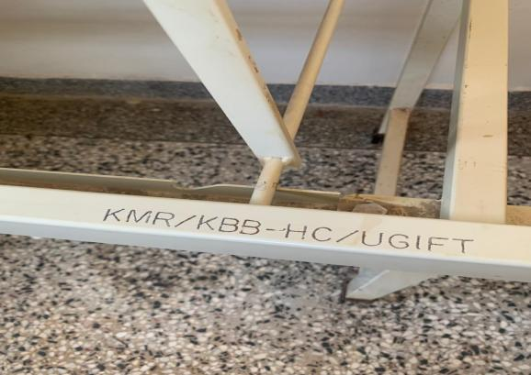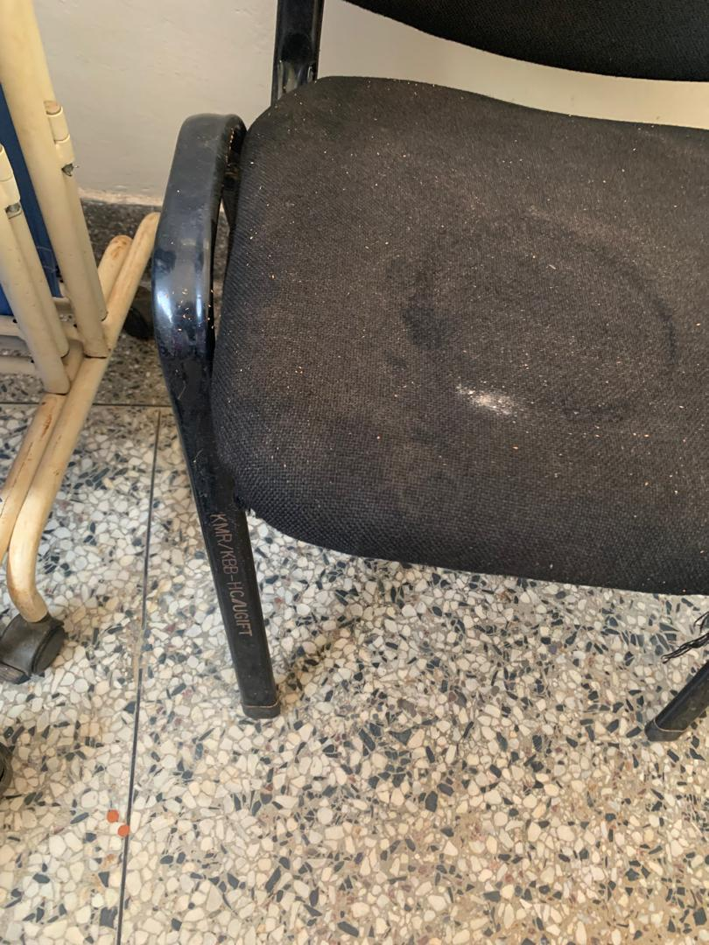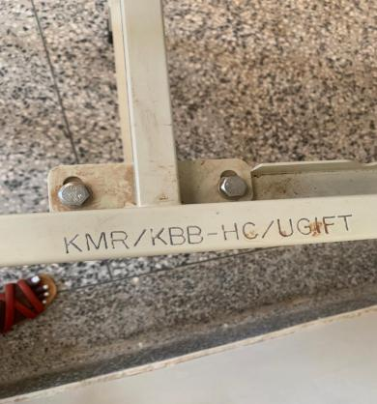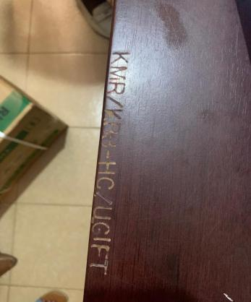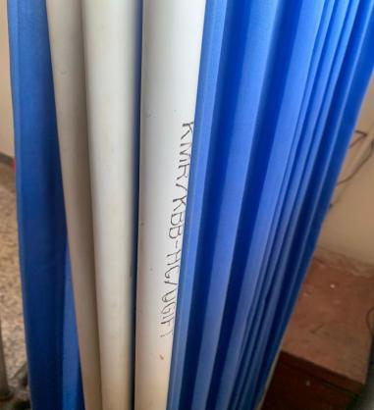

SCHOOL VERIFICATION CHECKLIST

SCHOOL INTERVIEW/DISCUSSION GUIDE

Name of school: ………………………………………………………………………………..

1a | Does the Facility have a record of all assets provided under UgIFT.  (Obtain a record and verify if it has the costs and numbers supplied
1b | If Not ask how many were supplied and when.

2 | How does this facility Maintain (repair/service/replace) the assets provided under Ugift

3 | Does the facility take regular record about functionality/ or breakdown of the assets provided?  Nonfunctional/ working, and reasons for non-functionality.

4 | How has the UgIFT support helped in service delivery in the area, any issues, challenges and any recommendations for better program implementation.

PROCEED TO VERIFICATION AFTER THIS DISCUSSION

SCHOOL FURNITURE
(School Desks, Office chairs, Laboratory stools, Book shelves)

Name of LG………………………………………………………………… Name of SCHOOL………………………………………………………………………………

Equipment/ Item | Department | Asset Number | Item  Description | Life in Months | Tag Number ( engrave no.) | Date Of Pur | Date Placed In Service | Recoverable cost | Cost | Acc Dep Cost | Net Book Value | Ytd Deprn | Equipment status | Remarks

ICT ITEMS TO VERIFY
(Desktop Computer, Server Processor, Network Switch 24 Port, Multipurpose Printer, UPS, Projector, Air Conditioners, Server, CCTV Camera)

Name of LG…………………………………………………………………………… Name of SCHOOL………………………….………………………………………

Equipment/ Item | Department | Asset Number | Item  Description | Life in Months | Tag Number ( engrave no.) | Date Of Pur | Date Placed In Service | Recoverable cost | Cost | Acc Dep Cost | Net Book Value | Ytd Deprn | Equipment status | Remarks

BUILDINGS TO VERIFY
(Non- Residential and Residential, Kitchen, Toilets/Pit latrine Water tanks, Fences etc.)

Name of LG…………………………………………………………………………… Name of SCHOOL………………………….………………………………………

Equipment/ Item | Department | Asset Number | Item  Description | Life in Months | Tag Number ( engrave no.) | Date Of Pur | Date Placed In Service | Recoverable cost | Cost | Acc Dep Cost | Net Book Value | Ytd Deprn | Equipment status | Remarks

